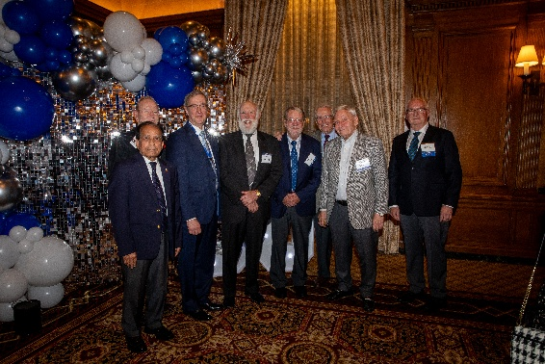
SEMCME Superheroes, 50th Anniversary Celebration, Detroit Athletic Club, Oct 2024
L to R: Vijay Mittal MD; Ronald Strickler MD; Steven Minnick MD; Robert Frank MD, David Pieper PhD, Tom Gentile MSA, Robert Sokol MD, Michael Geheb MD


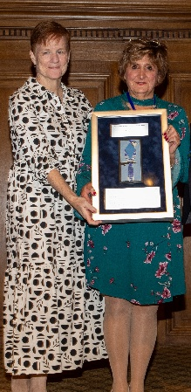
First Annual Ginger Keiffer Program Coordinators Award, October 2024,
L to R: Antoinette “Toni” Haddad, 1st award recipient; Ginger Keiffer, 38-year
employee of OHEP/SEMCME, retired June 2024

OHEP/SEMCME logos over the years

Salute to Past Presidents, 2007.
Standing, L to R: Mark Hannis MD; Francis Wilson MD, Steven Minnick MD; Thomas C Gentile Jr MSA; Kenneth L. Urwhiller MD; William Fuqua MD; John R. Pfeifer Jr. MD; R. Ralph Margulis MD; Frank Sottile MD; Willis Stephens MD; Michael Campbell; Ronald C. Strickler MD
Seated, L to R: Ernie Hammill PhD; Ruth Moore PhD; John R. Ylvisaker MD; Joseph Shirle Jr MD

